ELECTION ISSUE TO BE DECIDED

The general membership will elect two directors from the slate which has been presented by the Nominating Committee.
The candidate receiving the highest number of votes will serve a three-year term. The candidate receiving the next highest number of votes will serve a two-year term.

BALLOT INSTRUCTIONS

There are two (2) vacancies to be filled. There are two (2) votes for each timeshare interval owned (one for each board vacancy). The Bylaws (Article VII, Section 2) stipulate “Each member entitled to vote shall have the right in the election of directors to cumulate his votes.” This means you may cast all your votes for one candidate or split your votes in any way you choose, so long as you do not cast a total of more than two votes per interval owned. To emphasize this point, if you own one interval, you have two votes. If you own three intervals, you may cast six votes, etc.

Please indicate the number of votes you cast for each candidate by placing the number/s on the lines provided on the next page. Please Do not put an or , the line must contain a number. Please date the ballot, write in the interval #’s you own, sign the ballot, and print your name.

You may email your ballot to: egoff@arroyoroble.com

Or mail to:

Mr. Ralph Woellmer, GM
Arroyo Roble Resort
PO Box 2264
Sedona, Arizona 86339

NOTE: If you are in doubt about your interval number/s, you will find them printed on your owner’s card or just call us at 928-282-7777 Extension # 1131. Ballots not signed or improperly completed will be declared invalid and not be counted. Only one signature is required, but it must be an owner of record.

Arroyo Roble Resort Board of Directors Election Ballot – 2022

Please remember to indicate the number of votes you cast for each candidate by placing the number(s) on the lines provided. Please Do not put an or , the line must contain a number. Please date the ballot, write in the interval #’s you own, sign the ballot, and print your name. This page of the ballot may be returned via email, fax, or USPS mail to the resort at the address above.
Email the completed ballot to: egoff@arroyoroble.com or Mail to: Ralph Woellmer, GM. Arroyo Roble Resort, PO Box 2264, Sedona Arizona 86339

# Votes Candidate Name

________ Mr. Randy McGrane, Director

________ Mr. Scott Klarkowski, Director

________ Mr. Thomas Canepa, Homeowner

Date: __________ Interval Number(s): ____________________________

Owner Signature: _______________________________________________

Please Print Owner Name: ________________________________________
The following pages include biographical information on the three candidates for the 2022 Arroyo Roble Resort BOD elections.

Mr. Randy McGrane - Director

A founding partner of Ensemble Investments, Randy has decades of experience in commercial real estate. His background encompasses significant experience in development, acquisitions, dispositions, financing, underwriting, market analysis, and asset management. Randy plays a pivotal role in Ensemble's real estate investment business model. His full view of the market allows him to provide a value-added perspective on all transactions from deal structuring and entitlement to overseeing development activity through design and construction and acting as the “Principal In Charge” on numerous projects – including the Best Western Arroyo Roble Hotel.

Ensemble Investments is the owner of the Best Western Arroyo Robles and that includes 7 villas in our time share. Randy is committed to ensuring a positive relationship between these properties especially at this time when we are planning an expansion on the vacant land to the immediate north of the Time Share property. In addition, he has a vested interest in contributing to the Sedona community and is a strong supporter of the Sedona Arts Center. If elected he intends to offer a patient and measured approach to any updates and assist in identifying solutions that support the community.

Mr. Scott Klarkowski – Director

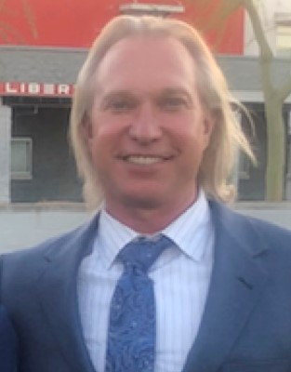

My name is Scott Klarkowski and I am running for reelection for 1 of the seats on the board of directors for the Arroyo Roble Resort. I have had the privilege of vacationing at this resort since my parents
purchased their first 2 weeks in 1984. I have a lot of memorable experiences as a child, at
the resort. After high school I continued my education at Scottsdale Community College,
however, I was looking for more of a challenge which led me to join the United State Marine
Corps and proudly served our Country. During my enlistment I continued to pursue my
education. I met my wife, Julie, married now for 25 years and Father to 3 amazing kids. I have
created several successful companies and have sold all but one of them. I am currently the
President of Big Kahuna Construction, which has been built from the ground up. During the
first few years of my children’s lives I would borrow a week from my mom so that my children
could experience and allow me to re capture some of the great memories growing up every
summer at Arroyo Roble. We currently own 6 weeks which I thoroughly enjoy the quality of
time I spend with my family there. With my background in construction and business management
and if appointed to the task, I would like to assist in overseeing what everyone’s expectations should
be for the resort if not exceed them. I live in the Valley, only an hour and half away. I have very much enjoyed being
a part of the board of directors and would like to continue my involvement in seeing that
Arroyo Roble be preserved.

Mr. Thomas Canepa – Homeowner

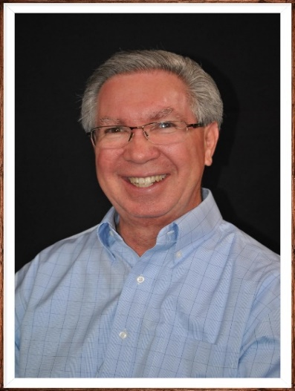

My wife and I have owned weeks at Arroyo Roble Resort for 25 years. We retired five years ago and currently live in the Westbrook Village community in Peoria, Arizona. We take the opportunity to visit Sedona and the Resort a couple times each year and have appreciated the on-going efforts to maintain and upgrade the Resort facilities. The beauty of Sedona and comfort of the Resort provide a wonderful respite from challenges of a big city.
I am a retired university administrator with 40+ years of experience in various administrative roles at public universities. Each position involved extensive budgetary management and fiscal responsibility, personnel functions, committee work and interaction with various public constituents.
I recently completed two 2-year terms as a board member of the Westbrook Village Association, serving on or chairing several committees during my tenure. I also served as Vice President for one year.
Following completion of bachelor’s and master’s degrees from the University of Arizona, I worked for Northern Arizona University for 20 years in various administrative positions. While at NAU I completed my doctoral degree in educational leadership. Most recently, I oversaw the admissions and financial aid offices for the University of Cincinnati, working with a staff of 80+ professionals to enroll over 5,000 new students each year.
I am very interested in participating in Board activities for the Resort and look forward to assisting the Board, General Manager, and staff to continue to keep Arroyo Roble a premier vacation location for our owners and guests.

