ELECTION ISSUE TO BE DECIDED

There were no additional homeowners willing to run for a position on the Board of Directors for the 2023 Election. Therefore, since there are only two candidates for this year’s election, the candidate receiving the highest number of votes will serve a three-year term. The candidate receiving the next highest number of votes will serve a two-year term.

BALLOT INSTRUCTIONS

There are two (2) vacancies to be filled. There are two (2) votes for each timeshare interval owned (one for each board vacancy). The Bylaws (Article VII, Section 2) stipulate “Each member entitled to vote shall have the right in the election of directors to cumulate his votes.” This means you may cast all your votes for one candidate or split your votes in any way you choose, so long as you do not cast a total of more than two votes per interval owned. To emphasize this point, if you own one interval, you have two votes. If you own three intervals, you may cast six votes, etc.

Please indicate the number of votes you cast for each candidate by placing the number/s on the lines provided on the next page. Please Do not put an or , the line must contain a number. Please date the ballot, write in the interval #’s you own, sign the ballot, and print your name.

You may email your ballot to: egoff@arroyoroble.com

Or mail to:

Ms. Esther Goff, Director of Owner Services
Arroyo Roble Resort
PO Box 2264
Sedona, Arizona 86339

NOTE: If you are in doubt about your interval number/s, you will find them printed on your owner’s card or just call us at 928-282-7777 Extension # 1131. Ballots not signed or improperly completed will be declared invalid and not be counted. Only one signature is required, but it must be an owner of record.

Arroyo Roble Resort Board of Directors Election Ballot – 2023

Please remember to indicate the number of votes you cast for each candidate by placing the number(s) on the lines provided. Please Do not put an or , the line must contain a number. Please date the ballot, write in the interval #’s you own, sign the ballot, and print your name. This page of the ballot may be returned via email, fax, or USPS mail to the resort at the address above.

Email the completed ballot to: egoff@arroyoroble.com or Mail to: Ms. Esther Goff, Director of Owner Services, Arroyo Roble Resort, PO Box 2264, Sedona Arizona 86339

# Votes Candidate Name

________ Ms. Sharon Trischan, Vice-President

________ Mr. Thomas Canepa, Secretary

Date: __________ Interval Number(s): ____________________________

Owner Signature: _______________________________________________

Please Print Owner Name: ________________________________________
The following pages include biographical information on the two candidates for the 2023 Arroyo Roble Resort BOD elections.

Ms. Sharon Trischan, Vice-President of the Board

I am once again delighted to have an opportunity of serving the owners of Arroyo Roble Resort Vacation Ownership as a member of your board of directors. We have seen many changes and improvements at the resort and I feel very honored of being part of the process. I am looking forward to being instrumental for future endeavors. I believe there are more exciting things to come keeping our resort up to date, maintaining its status as what I believe is the best place to stay in Sedona.

My background is varied. For over twenty years I was a realtor both in Arizona and in Upstate New York. Half of that time I owned my own brokerage. I left real estate and went into education serving the children and families in South Phoenix. I retired from education in 2013 from a district office position of Director of English Language Acquisition. I began my higher education as a business major. I went back to school and earned two Master of Education degrees, on in curriculum and the other in Education Leadership. My district office position involved managing several millions of dollars in multiple budgets.

My husband, John and I own multiple units at Arroyo Roble. My interest in continuing to serve on our board is the same as it was when I was first elected. It is to maintain and improve the integrity of our property while protecting our fiscal responsibility to our owners. My husband and I are world travelers and we own other vacation ownerships. We consider Arroyo Roble a home not just a vacation.

Mr. Thomas Canepa, Secretary of the Board

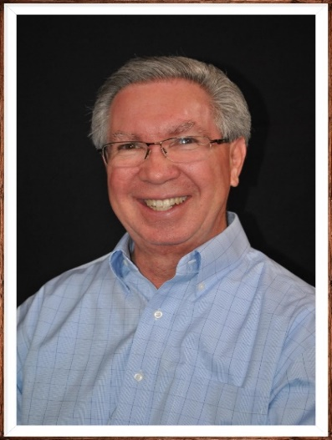

I have served as a member of the Board of Directors for the Arroyo Roble Resort for the past year, completing the term of a former board member, and serving as the Board Secretary.
My wife and I have owned weeks at Arroyo Roble Resort for over 25 years. We retired six years ago and currently live in the Westbrook Village community in Peoria, Arizona. We take the opportunity to visit Sedona and the Resort a couple of times each year and have appreciated the on-going efforts to maintain and upgrade the Resort facilities. The beauty of Sedona and comfort of the Resort provide a wonderful respite from the challenges of a big city.

I am a retired university administrator with 40+ years of experience in various administrative roles at public universities. Each position involved extensive budgetary management and fiscal responsibility, personnel functions, committee work and interaction with various public constituents.

I recently completed two 2-year terms as a board member of the Westbrook Village Association, serving on or chairing several committees during my tenure. I also served as Vice President for one year.

Following completion of bachelor’s and master’s degrees from the University of Arizona, I worked for Northern Arizona University for 20 years in various administrative positions. While at NAU I completed my doctoral degree in educational leadership. Most recently, I oversaw the admissions and financial aid offices for the University of Cincinnati, working with a staff of 80+ professionals to enroll over 5,000 new students each year.

I am very interested in continuing to participate in Board activities for the Resort and look forward to assisting the Board, General Manager, and staff to continue to keep Arroyo Roble a premier vacation location for our owners and guests.

